**Day 9 BA|DA TRAINING**

**Component Diagram:**

What is Component Diagram?

When modeling large object-oriented systems, it is necessary to break down the system into manageable subsystems. UML component diagrams are used for modeling large systems into smaller subsystems which can be easily managed.

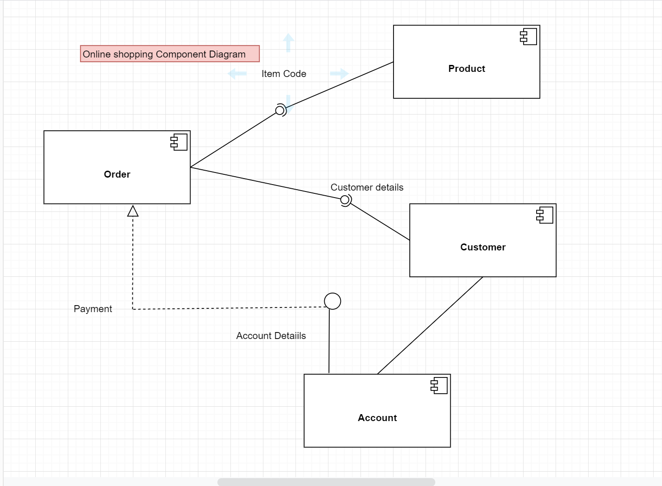

**object diagram:**

What is an Object Diagram?

Objects are the real-world entities whose behavior is defined by the classes. Objects are used to represent the static view of an object-oriented system. We cannot define an object without its class. Object and class diagrams are somewhat similar.

The difference between the class and object diagram is that the class diagram mainly represents the bird's eye view of a system which is also referred to as an abstract view. An object diagram describes the instance of a class. It visualizes the particular functionality of a system.

The above UML object diagram contains two objects named Ferrari and BMW which belong to a class named as a Car. The objects are nothing but real-world entities that are the instances of a class.

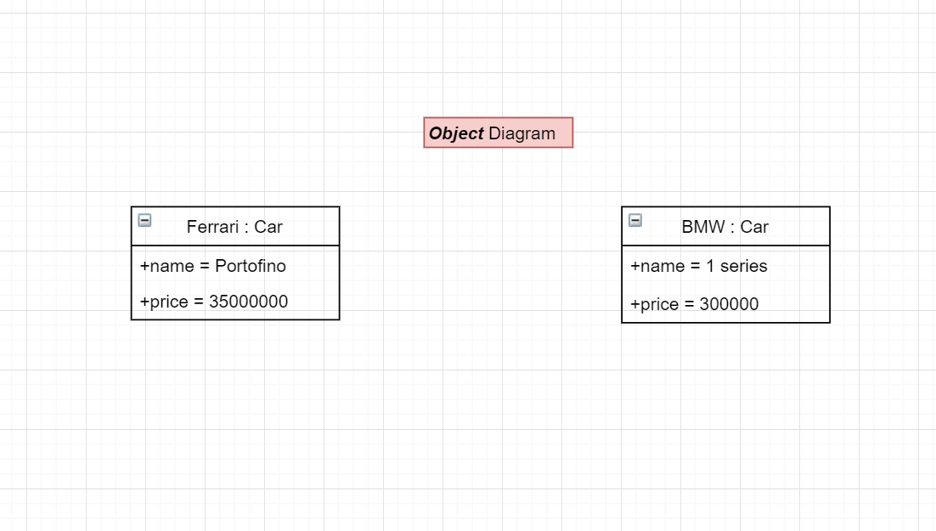

**Deployment Diagram:**

Deployment Diagram is a type of diagram that specifies the physical hardware on which the software system will execute. It also determines how the software is deployed on the underlying hardware. It maps software pieces of a system to the device that are going to execute it.

